**Design of Real Time weather monitoring instrument using Internet of thing Module**

**Name(s) : Sought Kumar sarangi, Abhishek kishor ,Shakeel Ahmed lone**

**Roll No(s) : CE21D300, CE23E009, CE23E012.**

**Course Details :** CE5525 -Atmospheric Physics and Chemistry

**Introduction:**

Max 300 words

**Literature Survey:**

Write a brief literature of the research you have done (Max 500 words)

**Objective of the study:**

State the objective of the project (Max 250 words)

* Design & Development of Wind anemometer, Rain gauge and vane
* Integration of sensor with IOT Board
* Internet of thing
* Real time Weather monitoring

**Methodology:**

State the methods used for the study with appropriate flow charts or figure (if required)

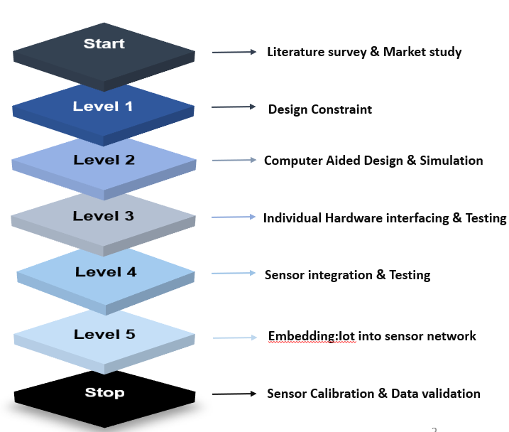

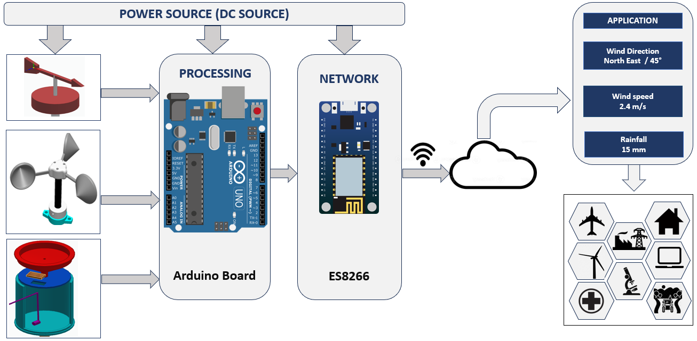

**Anemometer**

* four-cup anemometer developed by Robinson of Ireland in 1846.
* Pindado (2012) Test 21 different cup & arm model and find analytical model of Kondo et al.(1972) was proved to be accurate
* So, Observations from Lindley (1975) and pindado (2012) suggest that Cup Anemometer factor K factor to be 0.4(**Design constraint)**

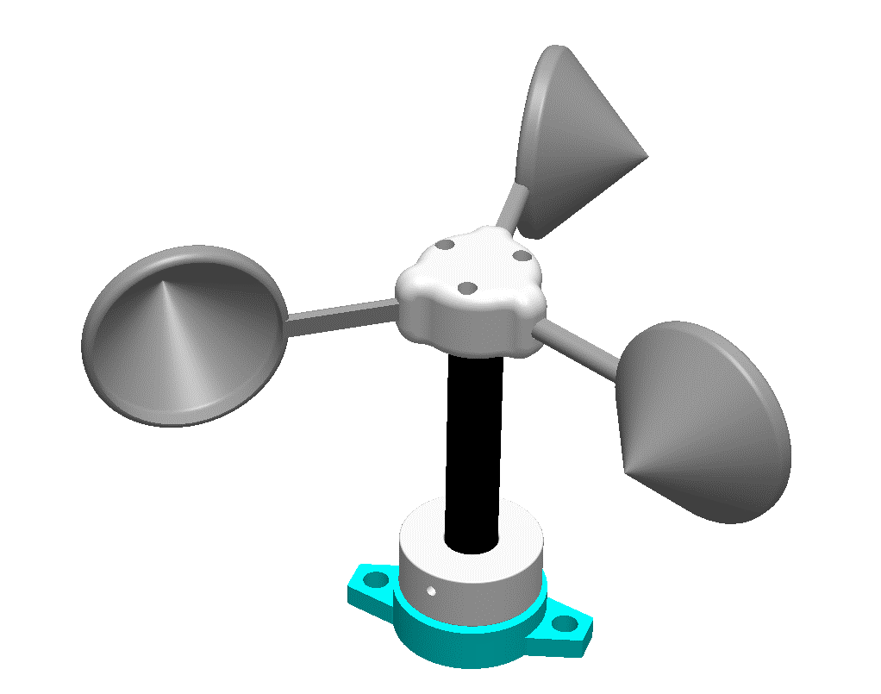

Cup arm

**Working principle:**



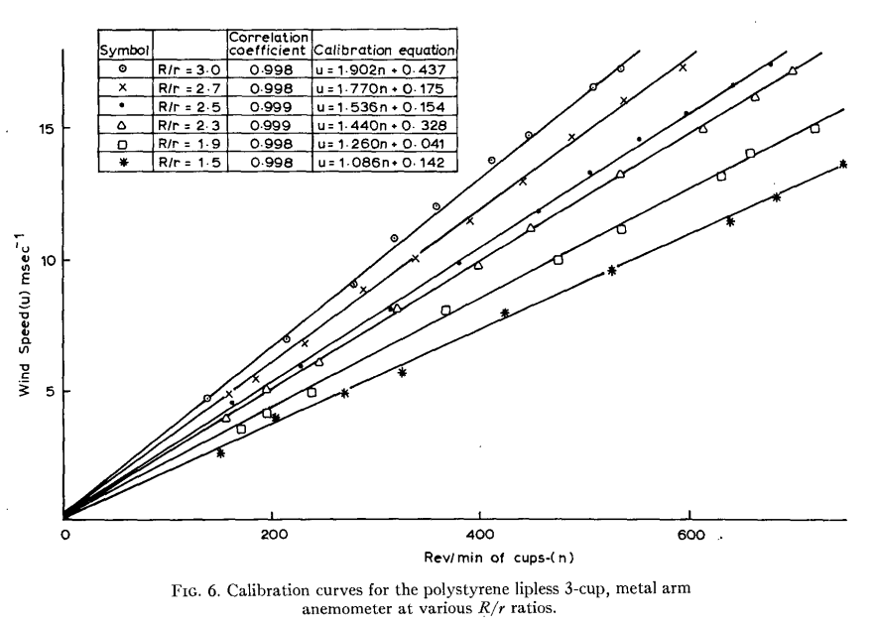

**Rain gauge**

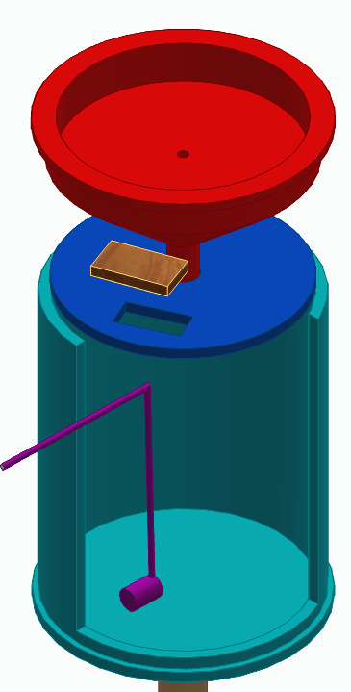

**Funnel**

**Ultrasonic sensor**

**Graduated**

**cylinder**

**Dc Pump**

**Working principle:**

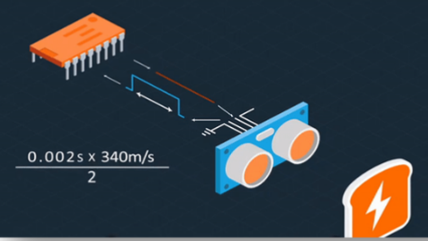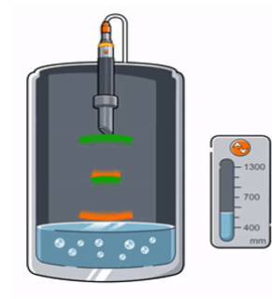

**Future work**

Wind vane:

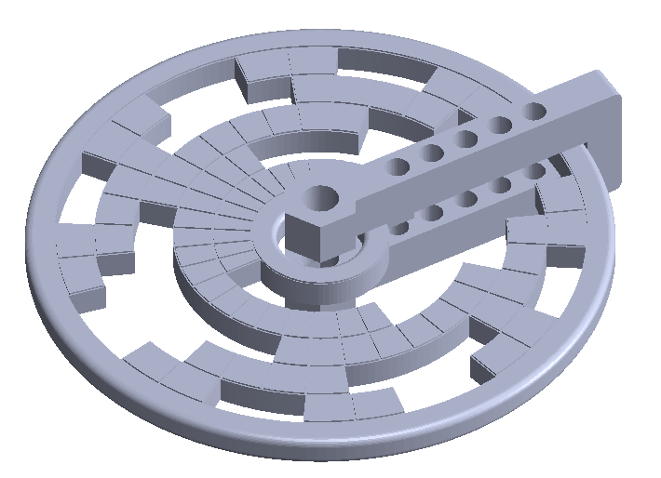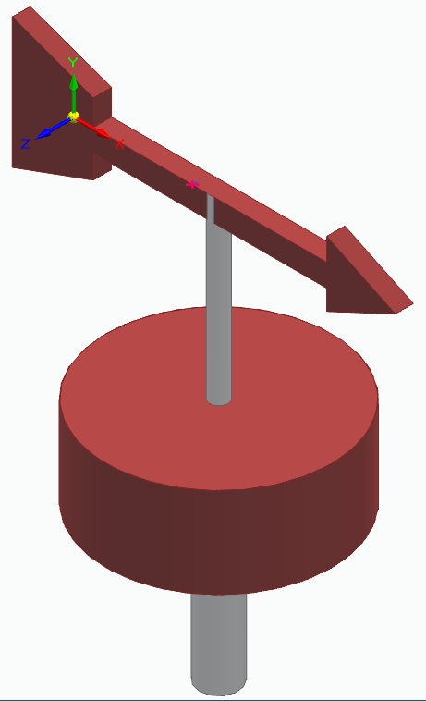

**Shaft**

**Vane**

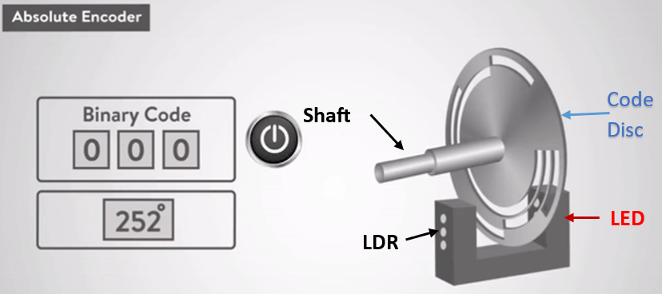**Working principle:**

Casing and assembly:

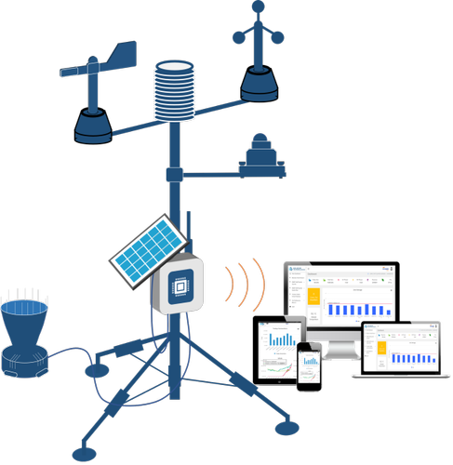

**Results and Discussion:**

Explain Results and Discussion from your project with neat figures and tables.

**Conclusions:**

Max 300 words.

**References:**

1. Avallone, E. *et al.* (2019) ‘An inexpensive anemometer using Arduino board’, *Facta universitatis - series: Electronics and Energetics*, 32(3), pp. 359–368. doi:10.2298/fuee1903359a.
2. Carlos-Mancilla, M.A. *et al.* (2020) ‘Educational mechatronics and internet of things: A case study on dynamic systems using meiot weather station’, *Sensors*, 21(1), p. 181. doi:10.3390/s21010181.
3. Coquilla, R.V., Obermeier, J. and White, B.R. (2007) ‘Calibration procedures and uncertainty in wind power anemometers’, *Wind Engineering*, 31(5), pp. 303–316. doi:10.1260/030952407783418720.
4. Lindley, D. (1975) ‘The design and performance of a 6-Cup anemometer’, *Journal of Applied Meteorology*, 14(6), pp. 1135–1145. doi:10.1175/1520-0450(1975)014&lt;1135:tdapoa&gt;2.0.co;2.
5. Pindado, S., Cubas, J. and Sorribes-Palmer, F. (2014) ‘The cup anemometer, a fundamental meteorological instrument for the wind energy industry. research at the IDR/UPM Institute’, *Sensors*, 14(11), pp. 21418–21452. doi:10.3390/s141121418.
6. Sharifabad, H.K., Mirzaei, O. and Talebi, M.H. (2011) ‘Design anemometer with transistor’, *Applied Mechanics and Materials*, 110–116, pp. 2628–2630. doi:10.4028/www.scientific.net/amm.110-116.2628.
7. Sheppard, P.A. (1940) ‘An improved design of cup anemometer’, *Journal of Scientific Instruments*, 17(9), pp. 218–221. doi:10.1088/0950-7671/17/9/301.

**Max 5 pages**